If I Were A Fur Trader/Voyageur
Where would I live?
You would have several bases where you work from, including a fort. You would trap and trade with Indians in the winter. You would return here every spring with your furs. You may also have a small cabin in the woods. It would be plastered with mud. There would be open holes for doors and windows. You might even have lived with the Indians.
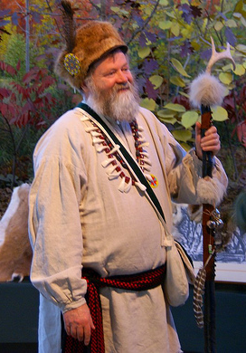
What would I wear?
Many of your clothes would be Indian clothes. You may wear breechcloths, leggings, and moccasins. They are made of animal skins. You would also have colorful cloth clothing too. You may wear red wool knit caps and bandanas on your head. You would also have cloth shirts and a bright sash around your waist. Fur robes and blankets would keep you warm in cold Michigan winters.

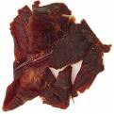
What would I eat?
If you were traveling, you may eat dried meat. This would be like jerky. It may be made of moose, elk, or deer. You may also eat pemmican. Pemmican is dried meat, wild nuts, and dried berries mixed with animal grease (usually bear fat). This held it together. It was a good meal. It would not spoil easily. It was also very easy to pack and carry. When visiting an Indian village, you would have a variety of foods offered to you. Then, you would eat soups, game (wild animals, including birds and fish), and other native foods.

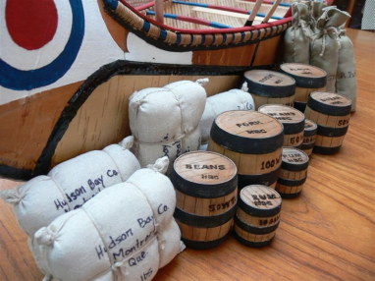
What kind of work would I do?
As a fur trader it would be your job to trade goods with the Indians. They would trade fur in exchange for goods they needed. In the fall you would provide Indians with blankets, guns, traps, cloth, flour, ribbon, beads, knives, kettles, alcohol, or other European goods. They needed things they couldn’t make themselves. In the spring, Indians would pay you with furs they trapped. Usually you were the employee of a fur company (French, Dutch, Canadian, British, or American). You got the goods you traded with the Indians from your fur company. But you might also be an independent fur trader. Under the French and the British, the independents were illegal.

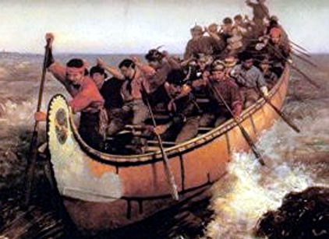
What would my life as a voyageur be like?
Voyageurs were tough men. They paddled the streams, rivers, and lakes. They carried trade goods and furs from outposts to the main forts. You would carry canoes and cargoes on your back to the next body of water. Their packs may weigh 180-200 pounds, but can weigh up to 300 pounds. They may paddle as much as 60-100 miles, and 15-18 hours a day.
As a voyageur, you would live this tough, hard-paced life because the fur trade was highly competitive. If you were a voyageur, you may often paddle the Great Lakes near the shorelines. You did this at night. You had to get your furs from the Indians and reach the forts before the other traders. Also, the lakes were calmer during the night. The waves got bigger when the sun came up and warmed the air.
Usually, voyageurs paddled for an hour, and then “took a pipe.” They rested their muscles for the time it took for the tobacco to burn. In the spring at voyageurs and Indians would return to the forts. This is called “rendezvous time.” They brought furs to take to the warehouses. The tribes came to trade furs and to receive treaty payments for their land. It was a time of celebration at the fort. Traders returned one by one and received their pay for their furs. There were lots of dances, banquets and celebrations.

What was my canoe like?
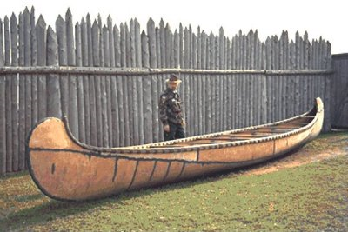
Indians taught you how to build and care for your canoe. Canoes were built with a wooden frame and covered with birch bark. The birch bark was stitched together with roots from pine trees. Pine sap, or pitch, was put on the seams as a waterproof seal. Pine pitch was carried along to make repairs. Paddles were made of maple wood. If cared for properly, a canoe could last as long as 10 years.
Your canoes are larger than Indian canoes. They had to be big enough to hold voyageurs and cargo. The North canoe was about 25 feet long. It held about eight voyageurs and 3,000 pounds of cargo. The Montreal canoe was even bigger. It was about 36 feet long. It held a crew of about 14 voyageurs to paddle it. It could hold several tons of furs.

How did we paddle such a big canoe?
You took turns paddling and steering the huge canoes. The voyageurs in the front and back of the canoe had longer paddles. These helped in steering.
The avant (a-vont) was in the front of the canoe to watch the water and help steer. His paddle was also long. The milieu (mil-you) was one of the middlemen. He knelt in the middle of the canoe. He also provided power using shorter paddles to push the water. He saved his energy in three ways. He paddled every other stroke, he paddled close to the boat, and he paddled lightly instead of digging deep into the water. The gouvernail (goo-ver-ni), meaning tiller, stood in the back of the canoe and used his long paddle to reach out and steer.
You often sang while traveling. This helped to keep up the rhythm of paddling and to stay awake. You would use bear grease on your hands to prevent blisters. You would use pine pitch as an insect repellent. You did this when paddling or walking through areas with mosquitoes.

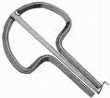
When I had the time, what did I do for fun?
Because of your traveling, everything you carried had to be small. Entertainment included songs and storytelling. Some voyageurs may have carried small musical instruments such as the Jew’s harp. Relaxation included “taking a pipe.” Sometimes you might race with another canoe or try to go down rapids that other voyageurs portaged. These activities could quickly turn to disaster and even death.
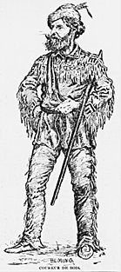
Who were the coureurs de bois?
They were “runners of the woods.” They were unlicensed fur traders who would get to the Indians to get their furs before you did. Under government laws (French and British) this was considered theft. You believed the unlicensed traders cheated the Indians as well.

How much money would I earn?
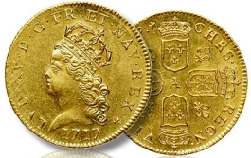
You worked to live. Some earned about $2,500 a year. Boatmen were paid about $83.00 a year. John Jacob Astor, owner of the American Fur Company, earned between one and two million dollars profit in 17 years.

