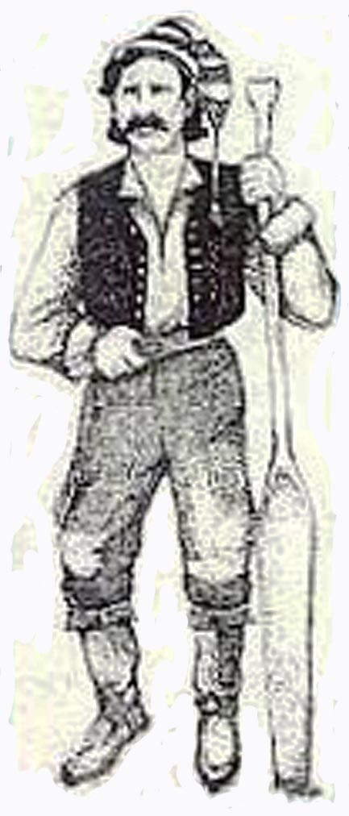

Word Bank

pemmican jerky leggings moccasins wool game blankets cloth beads kettles traps fur cargo paddle pipe pitch singing Jew’s harp storytelling

Name:__________________________ # ______ Date:___________________

Sensory Figure : Voyageur

With my hands I…

I ate…

I saw…

I felt…

I smelled…

I heard…