What’s Special About a Level J Book?
Fiction:
Each chapter is a self‐ contained story
1 or 2 characters together, like Mr. Putter and Tabby, Henry and Mudge, Frog and Toad, etc.
Characters don’t change much
Dialouge (talking) usually assigned to a speaker with signal words (said, cried, whispered)
Short stories within one chapter or a few chapters
Simple beginning, middle, and end; stories simple
May use literary language
Non-Fiction:
Short texts on familiar topics and easy narratives
Focus on familiar topics
May introduce new information
May offer a large amount of print with easy words
Has many frequently seen words, as well as some technical or unfamiliar words
Text Layout:
Print is in a larger font, with clear spaces between words and lines
Illustrations on most pages
Sentences usually return to the left margin to begin.
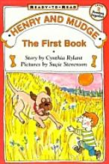
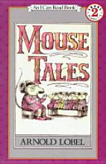
Great Examples:
Mouse Tales, Henry and Mudge

