What’s Special About a Level K Book?
Fiction:
Chapter books are still simple, but longer, with more text to read
Chapters are short; stories have multiple episodes related to a single plot but will be more to remember
Character usually encounters a problem then solves it
1-2 characters, with little development- usually one main trait
General dialogue, sometimes unassigned (without words like said)
Some stories based on ideas that are distant in space/time- readers use books to expand understanding of other cultures
Text more difficult- more multi-syllable words to decode

Non-Fiction:
Some technical language that is clearly explained within the book and include supportive illustrations/ pictures
Topics usually concrete- animals, plants, familiar ideas
Text shorter but difficult- different concepts presented on each page or each section

Text Layout:
Illustrations are less important to understanding the meaning of the text
Layout is friendly- sentences usually start at left margin
Print is in a large, clear font, with clear spaces between words
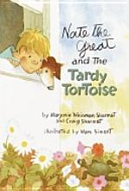
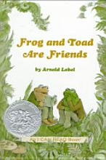
Great Examples:
Nate the Great and the Tardy Tortoise,
Frog and Toad are Friends

