What’s Special About a Level L Book?
Fiction:
Chapter books are longer and more complicated
Sequential chapters build upon one another
Characters likely to change and develop over the story
1 to 2 characters are featured- they have a dominant trait or two
Story may be connected to a theme
More sophisticated (plots) story lines; characters encounter a problem and then they solve it
Vocabulary includes multi-syllable words that may be unfamiliar
Has many easy and some harder frequently seen words

Non-Fiction:
Some new ideas presented but can be connected to own life
Number of new ideas presented is limited
Different ideas may be presented on each page or section
Simple biographies, recounting stories of the past, told in chronological/time order

Text Layout:
Font is smaller, with more print on the page
Illustrations on most pages, but some pages are just print
Layout is more difficult; sentences end in the middle of lines and continue on to the next line
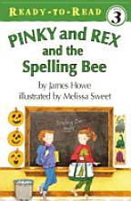
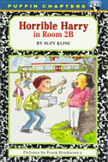
Great Examples:
Pinky and Rex and the Spelling Bee,
Horrible Harry in Room 2B

