What’s Special About a Level M Book?
Fiction:
Texts have many whole pages of print without pictures
Vocabulary is greatly expanded, including many multi-syllable and technical words.
Chapters are sequential, building upon one another.
Usually 1-2 main characters, with one dominant personality trait
Character encounters a problem, and then solves it.
Story may be connected to a theme.

Non-Fiction:
Topics are widely varied, from subjects that are familiar to new topics to study/learn.
Sections of text may provide different information, but there is elaboration to help the reader.
Most technical terms are explained and illustrated within the text.
Read biographies, structured as simple narratives, require reader to think about historical concepts.

Text Layout:
Illustrations usually black and white drawings or photos scattered through the text.
Pictures extend meaning and enhance enjoyment
Most texts have a smaller print with narrower word spacing
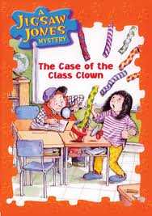
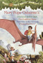
Great Examples:
Magic Tree House series,
Jigsaw Jones Mysteries

