What’s Special About a Level N Book?
Fiction:
Longer texts organized in a variety of ways.
Include well-developed, memorable characters that change in response to events in the story
Characters revealed through what they say, think, and do, as well as through what others say about them
Character has more than one obvious trait; changes over time
Much less clear that there is a single problem which is solved- there could be a problem within a problem, or that the situation is resolved, but not solved
Texts offer opportunity to feel empathy for characters, and to experience suspense
Literary devices such as irony and whimsy to create interest
Figurative language- more language play like puns, idioms, and metaphors

Non-Fiction:
Topics of informational texts and setting for narratives go well beyond readers’ personal experiences
Informational texts require much more content knowledge
Many technical words, usually explained within the text
Biographies longer and focus on subjects less well known to students
Expected to learn about subjects through reading.
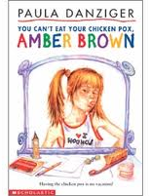
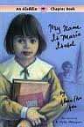

Great Examples:
Amber Brown series,
My Name is Maria Isabel

